23.31: a) 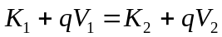
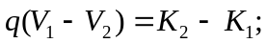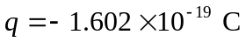
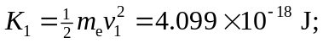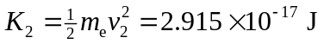
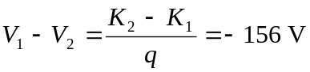
The electron gains kinetic energy when it moves to higher potential.
b) Now 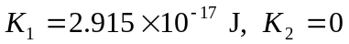
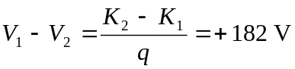
The electron loses kinetic energy when it moves to lower potential

